Email Swipe 3: Long-Term Change
SUBJECT: The Ripple Effect of Community Engagement

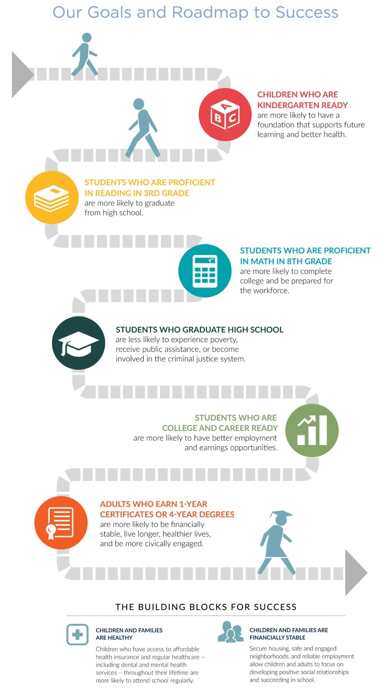 | United Way of Salt Lake goes beyond short-term charity for a few. They’re here to help every child, and every family, every step of the way — no matter their circumstances.  It starts with preparing kids for school and sticking with them as they grow.  Students who are ready for kindergarten are more likely to succeed in school. And those who succeed in school are more likely to graduate from high school.  This ripple effect continues into adulthood, creating access to more education, better-paying jobs, healthcare, and an improved overall quality of life.  With committed partners and donors like [Company Name], UWSL is working towards large-scale change that lasts.  They can’t do it alone. Will you help build brighter futures for Utah kids?  Donate >>> https://uw.org/donate/ or {insert custom donation link}

