Email Swipe 2: Last Day of Giving Campaign
SUBJECT: Last Chance! Support UWSL
or
Last Day of our Workplace Campaign – Give Today!
United Way of Salt Lake is tackling some of the toughest challenges we face, including poverty, poor health, and lagging achievement in education. And they’re starting locally in communities that need help the most.

UWSL relies on partners, volunteers, and investors to support their work and change the world. When we work together, we have the power to make lasting change for families right here in our own community.

With the help of generous community leaders like you, UWSL is fighting to make sure every child, and every family, in our community can be successful.

Take a look at all you've helped them accomplish:

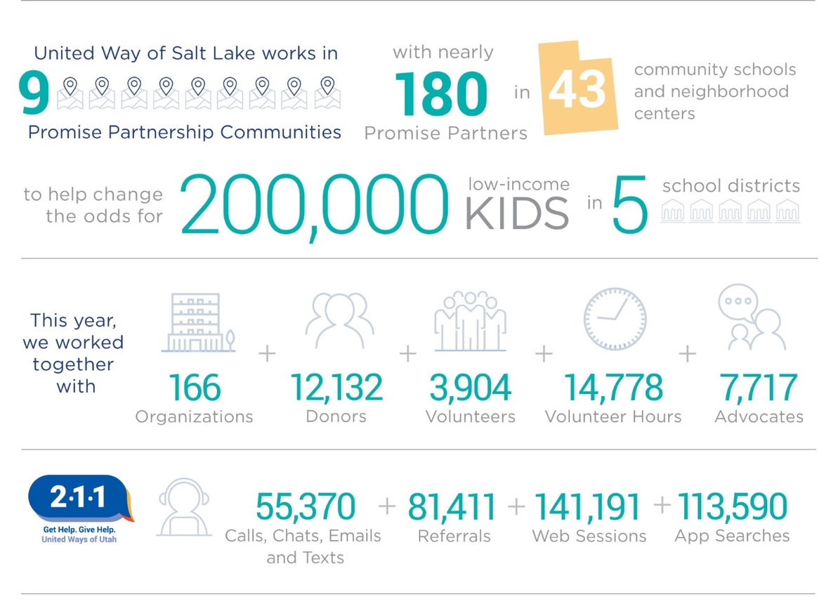

Donate today and help UWSL continue their work! Donate Today >>> https://uw.org/donate/ or {insert custom donation link}

