Email Swipe 4: Results that matter
SUBJECT: Results that Matter
United Way of Salt Lake is committed to getting results that matter – results that make a tangible difference in the lives of our friends and neighbors, right here in our community.

With the help of generous community members like you, they have been able to make a meaningful impact on outcomes for students in Salt Lake County.

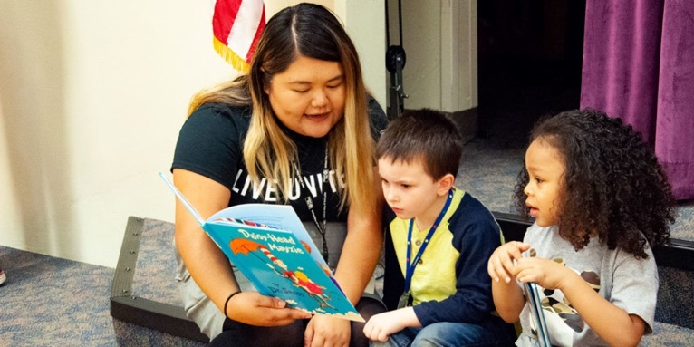
Children who are proficient at reading in 3rd grade are more likely to graduate from high school.
55% of low-income kindergarten students in our region are proficient in numeracy, up from 50% two years ago. 77% of third grade students at South Kearns Elementary are reading on grade level, up from 71% last year.

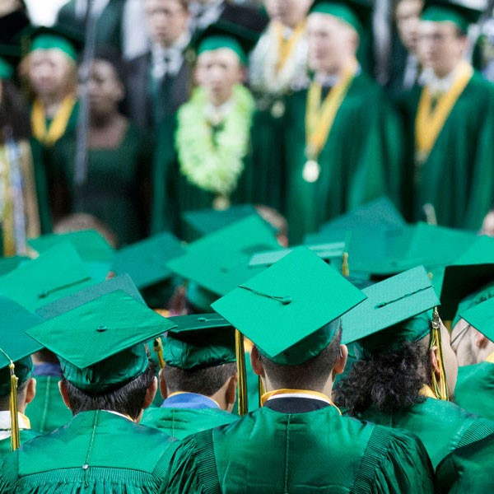
Students who graduate high school are less likely to experience poverty, receive public assistance, or become involved in the criminal justice system.
88% of low-income students at Cottonwood High School graduated, an increase of 10% from the previous year. And 7% more high school seniors have completed the FAFSA at schools in the FAFSA Impact and Improvement Network compared to last year, granting them access to financial aid needed to pursue a college education.
These are the results that matter. This is the power of what your generosity can do.

Help us continue our work? Donate >>> https://uw.org/donate/ or {insert custom donation link}

